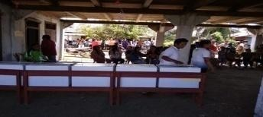
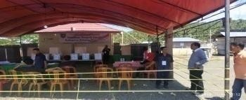
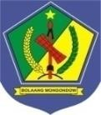
PEMERINTAH KABUPATEN BOLAANG MONGONDOW
SEKRETARIAT DAERAH
Jalan Trans Sulawesi, Desa Lalow, Kecamatan Lolak

NO | KECAMATAN | DESA | NAMA CALON | REKAPITULASI PEROLEHAN SUARA |  |  |  |  |  | KET
 |  |  |  | PEROLEHAN CALON | DPT | GUNAKAN HAK PILIH | TIDAK MEMILIH | SUARA SAH | TIDAK SAH | KET
1 | 2 | 3 | 4 | 5 | 6 | 7 | 8 | 9 | 10 | 11
1. | KEC. LOLAYAN | 1. DESA BOMBANON | 1. DENY HERNI JODY MAUN | 86 | 648 | 571 | 77 | 558 | 13 | 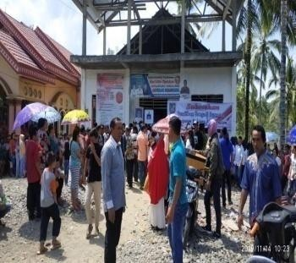
1. | KEC. LOLAYAN | 1. DESA BOMBANON | 2. TONNY DENNY KOLOPITA | 123
1. | KEC. LOLAYAN | 1. DESA BOMBANON | 3. GITA RATNASARI TUUK | 206
1. | KEC. LOLAYAN | 1. DESA BOMBANON | 4. NONI JENI GIGIR | 111
1. | KEC. LOLAYAN | 1. DESA BOMBANON | 5. SANDRA PONTOH, SE | 32
1. | KEC. LOLAYAN | 2. TAPA AOG | 1. DEBI ZAKAERDI | 115 | 950 | 865 | 85 | 862 | 3 | 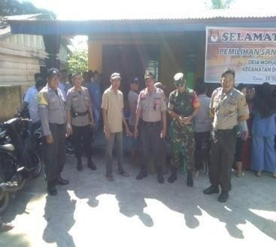
1. | KEC. LOLAYAN | 2. TAPA AOG | 2. RUSNI DONDO | 28
1. | KEC. LOLAYAN | 2. TAPA AOG | 3. CINDRAWATI PIRI | 333
1. | KEC. LOLAYAN | 2. TAPA AOG | 4. WAHYU A. THALIB | 292
1. | KEC. LOLAYAN | 2. TAPA AOG | 5. HARIYONO TUNGKAGI | 94
1. | KEC. LOLAYAN | 3. DESA MENGKANG | 1. ASNAN KOBANDAHA | 33 | 123 | 114 | 9 | 112 | 2
1. | KEC. LOLAYAN | 3. DESA MENGKANG | 2. LAM MAKALALAG | 79
1. | KEC. LOLAYAN | 4. DESA TANOYAN UTARA | 1. ELLY H. MOKOBOMBANG | 944 | 1.901 | 1.747 | 154 | 1.741 | -
1. | KEC. LOLAYAN | 4. DESA TANOYAN UTARA | 2. JEN PAPUTUNGAN | 18

1 | 2 | 3 | 4 | 5 | 6 | 7 | 8 | 9 | 10 | 11
 |  |  | 3. NURSAN ANSIK | 40 |  |  |  |  |  | 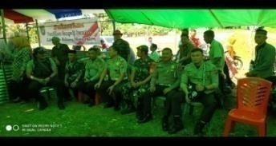
 |  |  | 4. SAMSUDIN MANGGO, SP | 730
 |  |  | 5. SRININGSIH KOBO, S.Pd | 9
2. | KEC. POIGAR | 1. DESA  NONAPAN BARU | 1. SILVIA HAYATI LIUNSANDA | 10 | 550 | 499 | 51 | 499 | - | 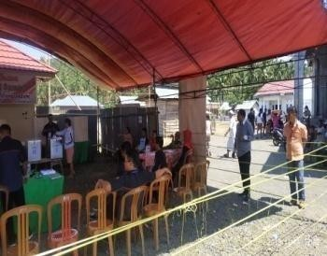
2. | KEC. POIGAR | 1. DESA  NONAPAN BARU | 2. SUNARIYO MAMONTO | 177
2. | KEC. POIGAR | 1. DESA  NONAPAN BARU | 3. ICON SINADIA | 183
2. | KEC. POIGAR | 1. DESA  NONAPAN BARU | 4. SULASTRI MAMONTO | 129
2. | KEC. POIGAR | 2. DESA  TANJUNG MARIRI | 1. DODI J. WONGKAR | 131 | 209 | 177 | 32 | 177 | - | 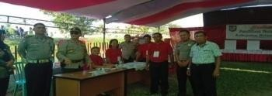
2. | KEC. POIGAR | 2. DESA  TANJUNG MARIRI | 2. LEXI TIGAU | 46
2. | KEC. POIGAR | 3. DESA MARIRI 1 | 1. NELWAN TILAAAR | 86 | 486 | 441 | 45 | 441 | - | 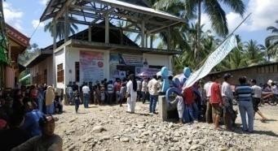
2. | KEC. POIGAR | 3. DESA MARIRI 1 | 2. JENTI RUMUAT, SH | 196
2. | KEC. POIGAR | 3. DESA MARIRI 1 | 3. KARNO JEKRI TAMBUN | 159
2. | KEC. POIGAR | 4. DESA  GOGALUMAN | 1. ELROY WAWOINTANA | 396 | 904 | 788 | 116 | 787 | 1 | 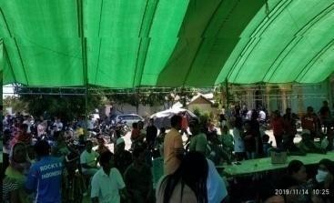
2. | KEC. POIGAR | 4. DESA  GOGALUMAN | 2. ALFRITS TAMAHIWU | 391
2. | KEC. POIGAR | 5. DESA  NONAPAN | 1. HARIS BALIK | 157 | 436 | 402 | 34 | 401 | 1 | 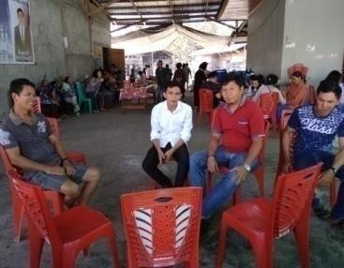
2. | KEC. POIGAR | 5. DESA  NONAPAN | 2. SARDJIMAN MOKODONGAN | 132
2. | KEC. POIGAR | 5. DESA  NONAPAN | 3. ANITA Z. MAKADOMO | 1
2. | KEC. POIGAR | 5. DESA  NONAPAN | 4. MARHAN MOKODONGAN | 111

1 | 2 | 3 | 4 | 5 | 6 | 7 | 8 | 9 | 10 | 11
 |  | 6. DESA  MONDATONG BARU | 1. SUHARDY MOHAMA | 152 | 306 | 289 | 17 | 289 | - | 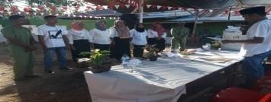
 |  | 6. DESA  MONDATONG BARU | 2. SUANTO MOKOGINTA | 137
 |  | 7. DESA  POMOMAN | 1. SUHARDI MOKODOMPIT | 55 | 215 | 192 | 23 | 191 | 1 | 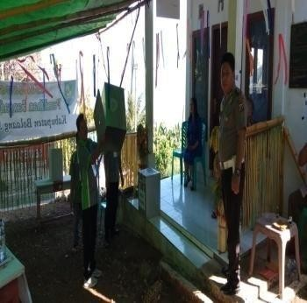
 |  | 7. DESA  POMOMAN | 2. MICHAEL M. P. PENDONG | 52
 |  | 7. DESA  POMOMAN | 3. CRISTINE H. SUMUNGE | 54
 |  | 7. DESA  POMOMAN | 4. MAGREYTA A. LANTU, S.Pd | -
 |  | 7. DESA  POMOMAN | 5. FERDINAN KARU | 30
 |  | 8. DESA NANASI TIMUR | 1. ALWIN D.K. KAWULUR | 64 | 621 | 495 | 126 | 495 | - | 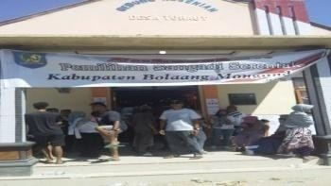
 |  | 8. DESA NANASI TIMUR | 2. HENTJE AFROON WINGKAR | 73
 |  | 8. DESA NANASI TIMUR | 3. HENGKI MONIGIR | 358
3. | KEC. LOLAK | 1. DESA SOLOG | 1. SUKARDI PAPUTUNGAN | 498 | 1.059 | 1.023 | 36 | 1.023 | - | 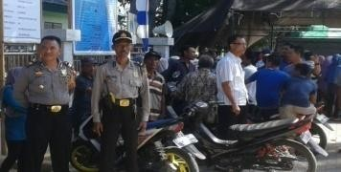
3. | KEC. LOLAK | 1. DESA SOLOG | 2. HALIPA BOLOTA | 44
3. | KEC. LOLAK | 1. DESA SOLOG | 3. HARDIONO KOBANDAHA | 481
3. | KEC. LOLAK | 2. DESA DIAT | 1. WAHYUDI TONGGI, S.Pd | 100 | 438 | 401 | 37 | 399 | 2 | 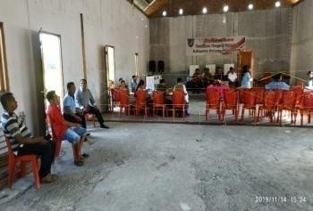
3. | KEC. LOLAK | 2. DESA DIAT | 2. HANAFI PAPUTUNGAN, S.Pd | 105
3. | KEC. LOLAK | 2. DESA DIAT | 3. ABDUL MUNIR DG MAULANA, S.Pd | 194
3. | KEC. LOLAK | 3. DESA TUYAT | 1. RALFIE POSUMA | 345 | 445 | 360 | 85 | 360 | - | 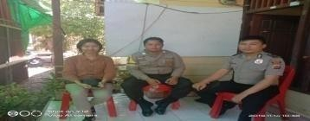
3. | KEC. LOLAK | 3. DESA TUYAT | 2. RENDI TAMAILANG | 15

1 | 2 | 3 | 4 | 5 | 6 | 7 | 8 | 9 | 10 | 11
 |  | 4. DESA LALOW | 1. BILDAD MAKAADOW | 246 | 1.338 | 1.143 | 195 | 1.125 | 18 | 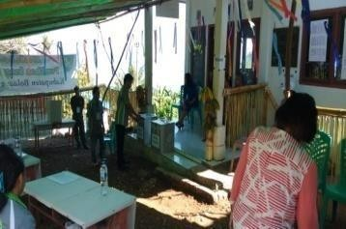
 |  | 4. DESA LALOW | 2. REFLI DONI TOPINUS | 268
 |  | 4. DESA LALOW | 3. STENDRY KASTILONG | 497
 |  | 4. DESA LALOW | 4. EVERDIX H. KASTILONG | 105
 |  | 4. DESA LALOW | 5. CHRISTIAN P. MADELLU | 9
 |  | 5. DESA LOLAK II | 1. SKIPER LALENO | 129 | 444 | 409 | 35 | 408 | 1 | 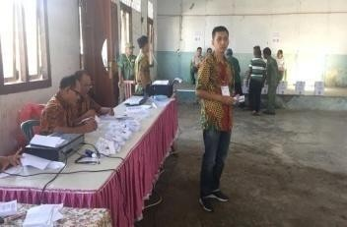
 |  | 5. DESA LOLAK II | 2. FRANLY YUSAK BERET | 90
 |  | 5. DESA LOLAK II | 3. Drs. GIDON JEFTA JALMAV | 125
 |  | 5. DESA LOLAK II | 4. FRENGKY PLANSIUS WAGIU | 64
 |  | 6. DESA LOLAK | 1. MAHYUDIN M. KALULUKU | 454 | 2.250 | 1.775 | 475 | 1.770 | 5 | 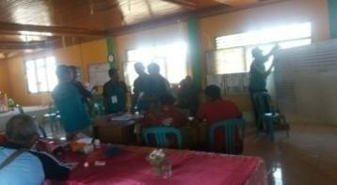
 |  | 6. DESA LOLAK | 2. SUNGE MONDONG PAPUTUNGAN | 54
 |  | 6. DESA LOLAK | 3. MUSTAFA HALAA | 716
 |  | 6. DESA LOLAK | 4. RISPAN PAPUTUNGAN | 546
 |  | 7. DESA DULANGON | 1. JEMI MANEKES | 33 | 453 | 401 | 52 | 397 | 4 | 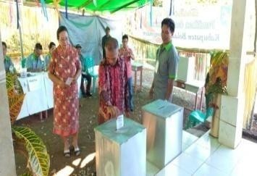
 |  | 7. DESA DULANGON | 2. ALFIAN GANSALENG | 5
 |  | 7. DESA DULANGON | 3. HALIM BADU | 18
 |  | 7. DESA DULANGON | 4. TRESYE MALONDA | 140
 |  | 7. DESA DULANGON | 5. JOHANIS PONTOH | 201
 |  | 8. DESA MONGKOINIT | 1. RONI PAPUTUNGAN | 209 | 1.412 | 1.226 | 186 | 1.221 | 5 | 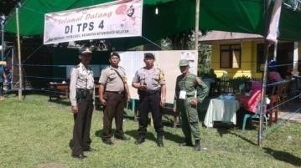
 |  | 8. DESA MONGKOINIT | 2. HERDIANTO PAPUTUNGAN | 599
 |  | 8. DESA MONGKOINIT | 3. ISWANDI PAPUTUNGAN | 341
 |  | 8. DESA MONGKOINIT | 4. HANAN DAMOPOLII | 72

1 | 2 | 3 | 4 | 5 | 6 | 7 | 8 | 9 | 10 | 11
 |  | 9. DESA BATURAPA | 1. TRSYEVONE KAKAHIS | 13 | 414 | 334 | 80 | 333 | 1 | 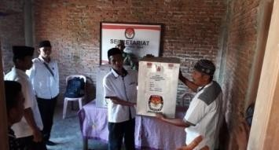
 |  | 9. DESA BATURAPA | 2. JOHANS MASABARE | 60
 |  | 9. DESA BATURAPA | 3. DURIEN B. ANDRIES | 99
 |  | 9. DESA BATURAPA | 4. YOLANDA KALIMBE | 161
 |  | 10. DESA  BUNTALO | 1. HENGKY SAITO | 235 | 698 | 592 | 106 | 589 | 3 | 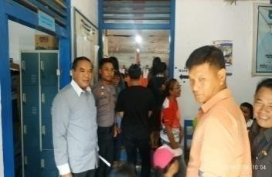
 |  | 10. DESA  BUNTALO | 2. ROYKE H. BAWOTONG | 38
 |  | 10. DESA  BUNTALO | 3. SELSIUS KATOHE | 181
 |  | 10. DESA  BUNTALO | 4. JOSIAS PONTOH | 75
 |  | 10. DESA  BUNTALO | 5. RUDO A. SUMOMBO | 60
 |  | 11. DESA  BUNTALO TIMUR | 1. ADRIANUS BAWURUNG | 11 | 487 | 410 | 77 | 408 | 2 | 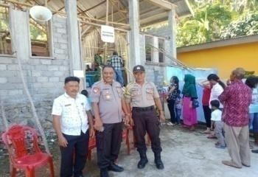
 |  | 11. DESA  BUNTALO TIMUR | 2. MARVEL TULUMBANG | 180
 |  | 11. DESA  BUNTALO TIMUR | 3. ADRI J. MANGANGUT | 43
 |  | 11. DESA  BUNTALO TIMUR | 4. JEFRISEL NANGKODA | 174
 |  | 12. DESA  BUNTALO SELATAN | 1. AGUSTINA ANTARA | 62 | 632 | 536 | 96 | 536 | - | 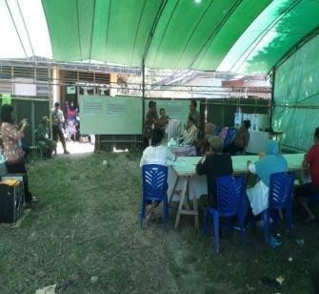
 |  | 12. DESA  BUNTALO SELATAN | 2. KRESTIAN MATEOS | 166
 |  | 12. DESA  BUNTALO SELATAN | 3. JOHANIS BENANG | 81
 |  | 12. DESA  BUNTALO SELATAN | 4. IMELDA PAPARANG | 94
 |  | 12. DESA  BUNTALO SELATAN | 5. HASLIVE BAKAR | 133

1 | 2 | 3 | 4 | 5 | 6 | 7 | 8 | 9 | 10 | 11
4. | KEC. SANGTOMBOLANG | 1. DESA DOMISIL MOONOW | 1. TAJUDIN OLII | 161 | 725 | 652 | 73 | 650 | 2 | 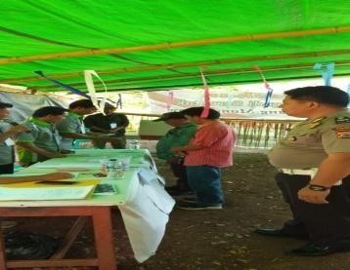
4. | KEC. SANGTOMBOLANG | 1. DESA DOMISIL MOONOW | 2. SIRAJUDIN KATILI | 283
4. | KEC. SANGTOMBOLANG | 1. DESA DOMISIL MOONOW | 3. ROHAYA MAMONTO | 41
4. | KEC. SANGTOMBOLANG | 1. DESA DOMISIL MOONOW | 4. NASIR DARWIS | 161
4. | KEC. SANGTOMBOLANG | 1. DESA DOMISIL MOONOW | 5. SALIM U. GONIMBALA | 4
4. | KEC. SANGTOMBOLANG | 2. DESA PANGI TIMUR | 1. ELVRIET I. LIWUTANG | 115 | 568 | 466 | 102 | 465 | 1 | 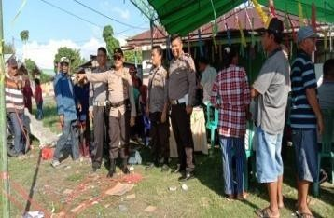
4. | KEC. SANGTOMBOLANG | 2. DESA PANGI TIMUR | 2. RISTISON TEMPOH | 155
4. | KEC. SANGTOMBOLANG | 2. DESA PANGI TIMUR | 3. NINI MOKOAGOW | 49
4. | KEC. SANGTOMBOLANG | 2. DESA PANGI TIMUR | 4. YON MASIRE | 146
4. | KEC. SANGTOMBOLANG | 3. DESA AYONG | 1. AMIR HAMSA MOODUTO | 246 | 1.073 | 942 | 131 | 937 | 5 | 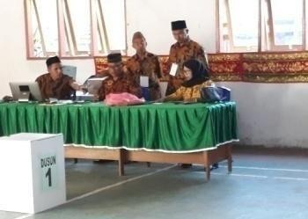
4. | KEC. SANGTOMBOLANG | 3. DESA AYONG | 2. ABDUL HARIS ALGAUS | 409
4. | KEC. SANGTOMBOLANG | 3. DESA AYONG | 3. MUHTAR MAMONTO | 203
4. | KEC. SANGTOMBOLANG | 3. DESA AYONG | 4. MALIK MOKODOMPIT | 79
4. | KEC. SANGTOMBOLANG | 4. DESA BOLANGAT | 1. AWALUDIN DILAPANGA | 246 | 827 | 730 | 97 | 725 | 5 | 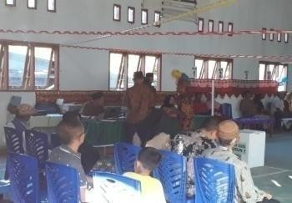
4. | KEC. SANGTOMBOLANG | 4. DESA BOLANGAT | 2. NOVRIE DONALD SINGKILAJA | 114
4. | KEC. SANGTOMBOLANG | 4. DESA BOLANGAT | 3. MARHAM PAPUTUNGAN | 213
4. | KEC. SANGTOMBOLANG | 4. DESA BOLANGAT | 4. MUSRIFAN SIMBALA | 152
4. | KEC. SANGTOMBOLANG | 5. DESA CEMPAKA | 1. RONAL HASAN | 159 | 440 | 391 | 49 | 391 | - | 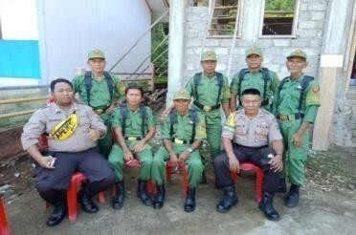
4. | KEC. SANGTOMBOLANG | 5. DESA CEMPAKA | 2. SAMSUDIN GAMA | 132
4. | KEC. SANGTOMBOLANG | 5. DESA CEMPAKA | 3. ASSE KASSI | 90
4. | KEC. SANGTOMBOLANG | 5. DESA CEMPAKA | 4. ISKANDAR TALIBE | 10

1 | 2 | 3 | 4 | 5 | 6 | 7 | 8 | 9 | 10 | 11
 |  | 6. DESA PASIR PUTIH | 1. MEYMUR DAUD | 51 | 328 | 268 | 60 | 268 | - | 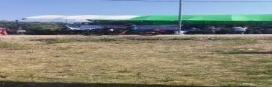
 |  | 6. DESA PASIR PUTIH | 2. SIMON DAUD | 217
 |  | 7. DESA BOLANGAT TIMUR | 1. FATMA DUHE | 29 | 295 | 255 | 40 | 254 | 1 | 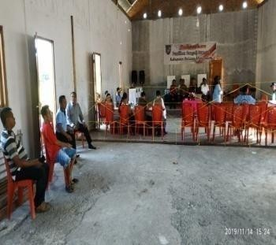
 |  | 7. DESA BOLANGAT TIMUR | 2. ONCI RONNY HIMPEDE | 84
 |  | 7. DESA BOLANGAT TIMUR | 3. OLFI MATU | 44
 |  | 7. DESA BOLANGAT TIMUR | 4. SONNY SISKA MASSIE | 59
 |  | 7. DESA BOLANGAT TIMUR | 5. MEIBRYZON LESSY | 38
5. | KEC. BOLAANG TIMUR | 1. DESA TADOY | 1. DENAN MANOPPO | 225 | 1.203 | 1.103 | 100 | 1.099 | 4 | 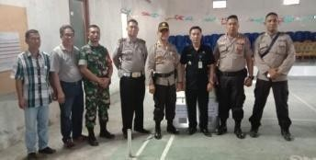
5. | KEC. BOLAANG TIMUR | 1. DESA TADOY | 2. KABOK PAPUTUNGAN | 523
5. | KEC. BOLAANG TIMUR | 1. DESA TADOY | 3. RIDWAN DILAPANGA | 351
5. | KEC. BOLAANG TIMUR | 2. DESA TADOY I | 1. RUSDIANTO DILAPANGA | 204 | 1.058 | 961 | 97 | 961 | - | 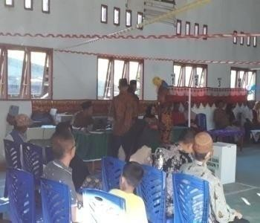
5. | KEC. BOLAANG TIMUR | 2. DESA TADOY I | 2. AGOAN PAPUTUNGAN | 76
5. | KEC. BOLAANG TIMUR | 2. DESA TADOY I | 3. YASIT MAMONTO | 325
5. | KEC. BOLAANG TIMUR | 2. DESA TADOY I | 4. RAMLAN PAPUTUNGAN | 335
5. | KEC. BOLAANG TIMUR | 2. DESA TADOY I | 5. BULOW MAMNTO | 21
5. | KEC. BOLAANG TIMUR | 3. DESA BOLAANG I | 1. ISNAINI PUHI | 608 | 822 | 780 | 42 | 779 | 1
5. | KEC. BOLAANG TIMUR | 3. DESA BOLAANG I | 2. KARMAN MAKALALAG | 171
5. | KEC. BOLAANG TIMUR | 4. DESA LOLAN II | 1. ALADIN GOBEL | 459 | 828 | 728 | 100 | 726 | 2
5. | KEC. BOLAANG TIMUR | 4. DESA LOLAN II | 2. ISWADY PAPUTUNGAN | 6
5. | KEC. BOLAANG TIMUR | 4. DESA LOLAN II | 3. ADEN MOKODOMPIT | -
5. | KEC. BOLAANG TIMUR | 4. DESA LOLAN II | 4. RUDI MOKODOMPIT | 261

1 | 2 | 3 | 4 | 5 | 6 | 7 | 8 | 9 | 10 | 11
6. | KEC. BOLAANG | 1. DESA  KOMANGAAN | 1. KAMSI MAMONTO | 54 | 1.792 | 1.430 | 362 | 1.425 | 5 | 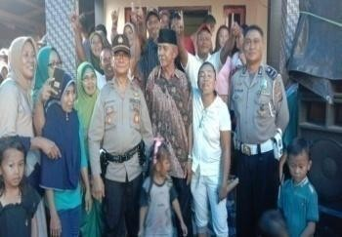
6. | KEC. BOLAANG | 1. DESA  KOMANGAAN | 2. SABIR PAPUTUNGAN | 562
6. | KEC. BOLAANG | 1. DESA  KOMANGAAN | 3. MAIDIN BALUNTU | 354
6. | KEC. BOLAANG | 1. DESA  KOMANGAAN | 4. IDRIS MAMONTO | 455
6. | KEC. BOLAANG | 2. DESA  SOLIMANDUNG AN I | 1. SARTIKA DAENG MASENGE | 356 | 815 | 752 | 63 | 752 | - | 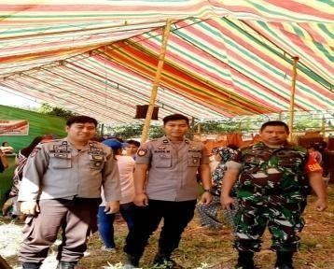
6. | KEC. BOLAANG | 2. DESA  SOLIMANDUNG AN I | 2. SAMDIN MAKALALAG | 245
6. | KEC. BOLAANG | 2. DESA  SOLIMANDUNG AN I | 3. UYODONG GINOGA | 139
6. | KEC. BOLAANG | 2. DESA  SOLIMANDUNG AN I | 4. JERI MOKOGINTA | 12
6. | KEC. BOLAANG | 3. DESA  BANGOMULUN OW | 1. RAHMATIA MOKODONGAN | 392 | 1.018 | 974 | 44 | 967 | 7 | 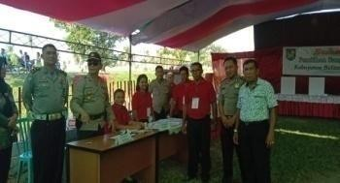
6. | KEC. BOLAANG | 3. DESA  BANGOMULUN OW | 2. FARID ALHASNI | 362
6. | KEC. BOLAANG | 3. DESA  BANGOMULUN OW | 3. ISMA DAENG PALALO | 213
6. | KEC. BOLAANG | 4. DESA  LANGAGON | 1. SAHIDIN MOKODOMPIT | 100 | 1.410 | 1.141 | 269 | 1.136 | 5 | 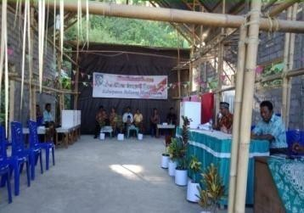
6. | KEC. BOLAANG | 4. DESA  LANGAGON | 2. TANTI MOKODOMPIT | 2
6. | KEC. BOLAANG | 4. DESA  LANGAGON | 3. HAMKA MAMONTO | 238
6. | KEC. BOLAANG | 4. DESA  LANGAGON | 4. ADUN S. POTABUGA | 796
6. | KEC. BOLAANG | 5. DESA  INOBONTO II | 1. YANIS RODAYA | 67 | 1.295 | 1.014 | 281 | 1.012 | 2 | 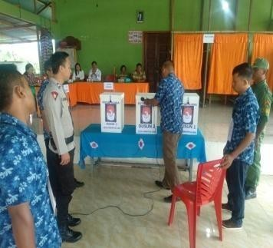
6. | KEC. BOLAANG | 5. DESA  INOBONTO II | 2. FEBBY MAC DONAL JANIS | 24
6. | KEC. BOLAANG | 5. DESA  INOBONTO II | 3. YOHANIS TATAMBIHE | 271
6. | KEC. BOLAANG | 5. DESA  INOBONTO II | 4. TOMMY FRANS HARIKADUA | 87
6. | KEC. BOLAANG | 5. DESA  INOBONTO II | 5. ADRIANUS OROH | 563

1 | 2 | 3 | 4 | 5 | 6 | 7 | 8 | 9 | 10 | 11
 |  | 6. DESA  INOBONTO | 1. LOMAT OLII | 447 | 1.268 | 1.039 | 229 | 1.034 | 5 | 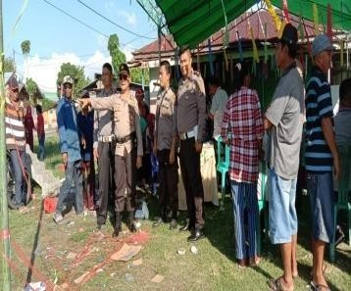
 |  | 6. DESA  INOBONTO | 2. JUSDAN POTABUGA | 75
 |  | 6. DESA  INOBONTO | 3. RAMLI POTABUGA | 20
 |  | 6. DESA  INOBONTO | 4. MUSRIF BENENEHU | 49
 |  | 6. DESA  INOBONTO | 5. KAMIL PAPUTUNGAN, S.Pd | 413
 |  | 7. DESA  LANGAGON I | 1. ABDUL AGUS GAIB | 22 | 741 | 628 | 113 | 628 | - | 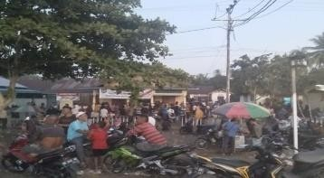
 |  | 7. DESA  LANGAGON I | 2. HIRAWANTO VAN GOBEL | 291
 |  | 7. DESA  LANGAGON I | 3. HAIRIL POTABUGA | 315
 |  | 8. DESA  LANGAGON II | 1. FREDY EFENDI SIKOME | 89 | 478 | 413 | 65 | 411 | 2 | 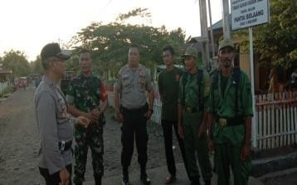
 |  | 8. DESA  LANGAGON II | 2. WILKA GILING | 206
 |  | 8. DESA  LANGAGON II | 3. MEISYE TAMAMILANG | 116
 |  | 9. DESA  SOLIMANDUN GAN BARU | 1. JOIS MOKODOMPIT | 48 | 742 | 657 | 85 | 653 | 4 | 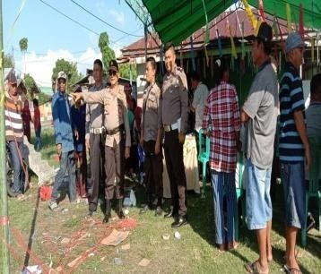
 |  | 9. DESA  SOLIMANDUN GAN BARU | 2. AJAN MOKOAGOW | 267
 |  | 9. DESA  SOLIMANDUN GAN BARU | 3. FARUK B. BAHMID | 6
 |  | 9. DESA  SOLIMANDUN GAN BARU | 4. MUH. ASRI MOKODONGAN | 243
 |  | 9. DESA  SOLIMANDUN GAN BARU | 5. CHERY MKODOMPIT | 89
7. | KEC. DUMOGA | 1. DESA  SINIYUNG I | 1. CHANDRA TAMBAJONG | 129 | 468 | 400 | 68 | 397 | 3 | 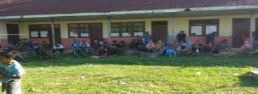
7. | KEC. DUMOGA | 1. DESA  SINIYUNG I | 2. MOUVE MEIKY MEWENGKANG | 268

1 | 2 | 3 | 4 | 5 | 6 | 7 | 8 | 9 | 10 | 11
 |  | 2. DESA  SINIYUNG | 1. ZAKIUS MANGGOPA | 16 | 1.354 | 1.287 | 67 | 1.285 | 2 | 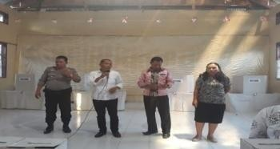
 |  | 2. DESA  SINIYUNG | 2. FRANGKY MANGGOPA | 560
 |  | 2. DESA  SINIYUNG | 3. OSLAN LAURENS, SE | 709
 |  | 3. DESA  PONOMPIAAN | 1. YOUKE MONIUNG, S.Md | 485 | 1.469 | 1.303 | 166 | 1.300 | 3 | 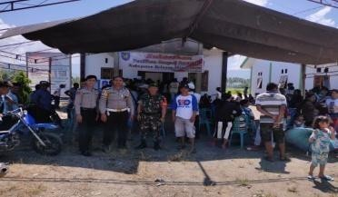
 |  | 3. DESA  PONOMPIAAN | 2. MAX SARUNDAJANG, BA | 424
 |  | 3. DESA  PONOMPIAAN | 3. BOB JHON R. WALUYANTO | 391
 |  | 4. DESA  BUMBUNGON | 1. HAYATI MUMEK | 31 | 955 | 890 | 65 | 884 | 6 | 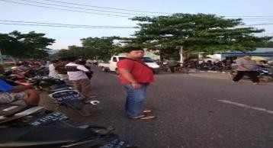
 |  | 4. DESA  BUMBUNGON | 2. VEKY V. POTOAN, S.Pd | 445
 |  | 4. DESA  BUMBUNGON | 3. VRITJE D. SUPIT | 408
 |  | 5. DESA  TORUAKAT | 1. TOMI MOKOBELA | 1.109 | 1.778 | 1.703 | 75 | 1.702 | 1 | 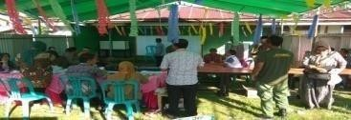
 |  | 5. DESA  TORUAKAT | 2. RIFAI DAMOPOLII | 593
 |  | 6. DESA  MOTOTABIAN | 1. REINHARD S. J. TATAUNG | 15 | 379 | 326 | 53 | 326 | - | 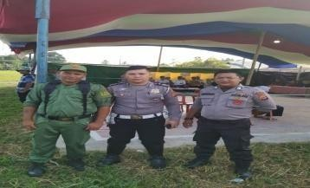
 |  | 6. DESA  MOTOTABIAN | 2. HANNA LILA | 203
 |  | 6. DESA  MOTOTABIAN | 3. RYANTI JOUKE KALIA | 108
 |  | 7. DESA  DUMOGA I | 1. JAMES LAHID, S.IP | 189 | 680 | 559 | 121 | 556 | 3 | 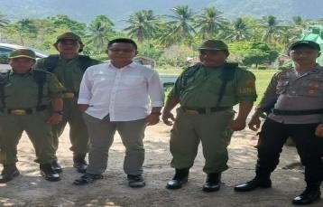
 |  | 7. DESA  DUMOGA I | 2. IT AKUBA | 32
 |  | 7. DESA  DUMOGA I | 3. HESTI DEVI SALU | 61
 |  | 7. DESA  DUMOGA I | 4. SELDRIN APANGA, Amd.Kep | 277

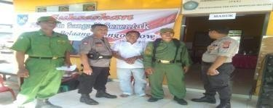
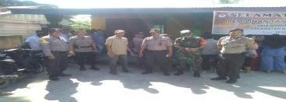
1 | 2 | 3 | 4 | 5 | 6 | 7 | 8 | 9 | 10 | 11
8. | KEC. DUMOGA UTARA | 1. DESA MOPUYA UTARA | 1. MUHAMMAD SUYONO | 59 | 1.068 | 925 | 143 | 920 | 5 | 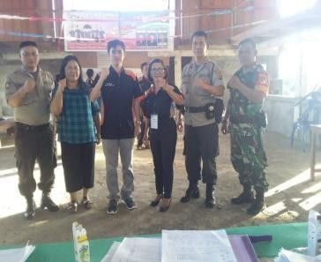
8. | KEC. DUMOGA UTARA | 1. DESA MOPUYA UTARA | 2. SAGINO | 64
8. | KEC. DUMOGA UTARA | 1. DESA MOPUYA UTARA | 3. TASER | 135
8. | KEC. DUMOGA UTARA | 1. DESA MOPUYA UTARA | 4. AHMAD MUAIMIN | 285
8. | KEC. DUMOGA UTARA | 1. DESA MOPUYA UTARA | 5. MUJIHARJO PESIK | 377
8. | KEC. DUMOGA UTARA | 2. DESA MOPUGAD SELATAN | 1. I MADE MERTA | 281 | 565 | 503 | 62 | 502 | 1
8. | KEC. DUMOGA UTARA | 2. DESA MOPUGAD SELATAN | 2. I WAYAN GARA | 221
8. | KEC. DUMOGA UTARA | 3. DESA MOPUGAD SELATAN I | 1. I KETUT ARTA | 155 | 506 | 450 | 56 | 449 | 1
8. | KEC. DUMOGA UTARA | 3. DESA MOPUGAD SELATAN I | 2. I KETUT SUBAGIAMA | 294
8. | KEC. DUMOGA UTARA | 4. DESA  DONDOMON UTARA | 1. FERDJI MANGOAL | 67 | 370 | 353 | 17 | 350 | 3 | 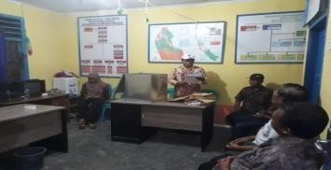
8. | KEC. DUMOGA UTARA | 4. DESA  DONDOMON UTARA | 2. DENI ROY PIAY | 29
8. | KEC. DUMOGA UTARA | 4. DESA  DONDOMON UTARA | 3. STENLY JANI KAWUNG | 159
8. | KEC. DUMOGA UTARA | 4. DESA  DONDOMON UTARA | 4. AUDY H. PINATIK | 95
9. | KEC. DUMOGA TENGGARA | 1. DESA  BONAWANG | 1. HAMIDIN MANGGO | 29 | 231 | 219 | 12 | 219 | - | 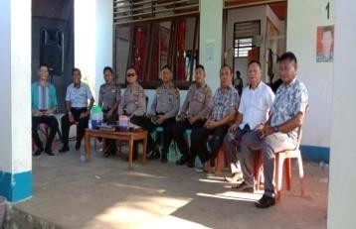
9. | KEC. DUMOGA TENGGARA | 1. DESA  BONAWANG | 2. YASMIN BANDAHARA | 11
9. | KEC. DUMOGA TENGGARA | 1. DESA  BONAWANG | 3. RUSBINAN PASI | 165
9. | KEC. DUMOGA TENGGARA | 1. DESA  BONAWANG | 4. SUTANTI OLOLAH | 14
9. | KEC. DUMOGA TENGGARA | 2. DESA DUMARA | 1. SAIPUDIN DJANGKARANG | 419 | 716 | 680 | 36 | 676 | 4 | 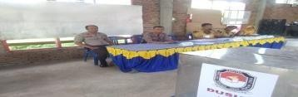
9. | KEC. DUMOGA TENGGARA | 2. DESA DUMARA | 2. ROSNANI MOHAMA | 257
9. | KEC. DUMOGA TENGGARA | 3. DESA IKUNA | 1. MULIONO MAMONTO | 375 | 610 | 598 | 12 | 597 | 1
9. | KEC. DUMOGA TENGGARA | 3. DESA IKUNA | 2. ISNAN MOKODOMPIT | 222

1 | 2 | 3 | 4 | 5 | 6 | 7 | 8 | 9 | 10 | 11
 |  | 4. DESA  KONAROM | 1. MILIAM EGAM | 20 | 694 | 646 | 48 | 634 | 12 | 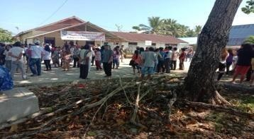
 |  | 4. DESA  KONAROM | 2. BOBY BONDE | 153
 |  | 4. DESA  KONAROM | 3. FADAL A. MAMONTO | 461
 |  | 5. DESA OSION | 1. SURYO MAMONTO | 66 | 513 | 496 | 17 | 495 | 1 | 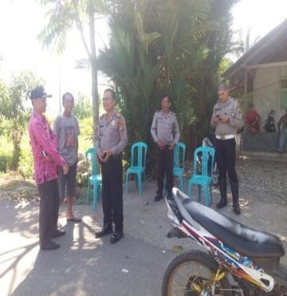
 |  | 5. DESA OSION | 2. SABRIA BONDE | 52
 |  | 5. DESA OSION | 3. ISMAELA PAPUTUNGAN | 66
 |  | 5. DESA OSION | 4. JUANDA MAMONTO | 140
 |  | 5. DESA OSION | 5. SUHARIADI POTABUGA | 171
 |  | 6. DESA  TAPADAKA TIMUR | 1. FERAWATI LALILI, S.Md | 108 | 414 | 380 | 34 | 378 | 2 | 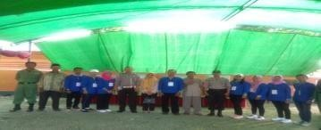
 |  | 6. DESA  TAPADAKA TIMUR | 2. RAMLI SUGEHA | 270
 |  | 7. DESA  KONAROM UTARA | 1. RUSLI BETARI | 155 | 470 | 406 | 64 | 403 | 3 | 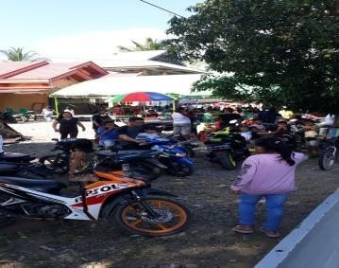
 |  | 7. DESA  KONAROM UTARA | 2. BAHLIAN LOMPAD | 75
 |  | 7. DESA  KONAROM UTARA | 3. MASRI DAMUDALAN | 133
 |  | 7. DESA  KONAROM UTARA | 4. JUFRI GUGUNE | 40

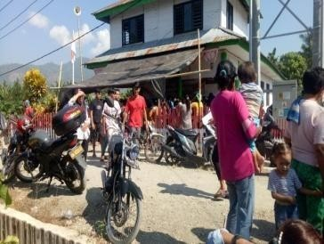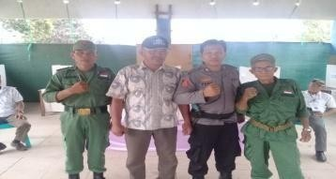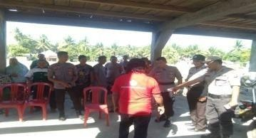
1 | 2 | 3 | 4 | 5 | 6 | 7 | 8 | 9 | 10 | 11
 |  | 8. DESA  TAPADAKA I | 1. HIJUL RAMPAN | 12 | 780 | 682 | 98 | 682 | - | 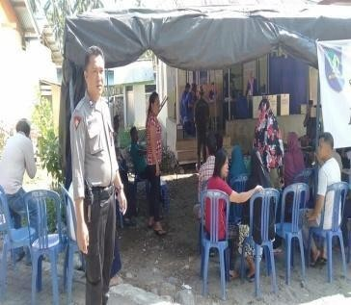
 |  | 8. DESA  TAPADAKA I | 2. AMONG KANGKI | 324
 |  | 8. DESA  TAPADAKA I | 3. HALINA MANGGO | 112
 |  | 8. DESA  TAPADAKA I | 4. ELFIA RAMPAN | 22
 |  | 8. DESA  TAPADAKA I | 5. JIWANDONO TEGELA | 212
10. | KEC. DUMOGA TENGAH | 1. DESA IBOLIAN | 1. RATNA MAMONTO | 566 | 1.797 | 1.708 | 89 | 1.701 | 7
10. | KEC. DUMOGA TENGAH | 1. DESA IBOLIAN | 2. KUSMAN MAMONTO | 661
10. | KEC. DUMOGA TENGAH | 1. DESA IBOLIAN | 3. ARIF BONDE | 474
10. | KEC. DUMOGA TENGAH | 2. DESA IBOLIAN I | 1. FRENGKY PANDELAKI | 112 | 368 | 340 | 28 | 340 | -
10. | KEC. DUMOGA TENGAH | 2. DESA IBOLIAN I | 2. SONNY POLII | 98
10. | KEC. DUMOGA TENGAH | 2. DESA IBOLIAN I | 3. TARTIUS ELIZA UNEPUTLI | 54
10. | KEC. DUMOGA TENGAH | 2. DESA IBOLIAN I | 4. ASARIA PAUDU, SP | 76
10. | KEC. DUMOGA TENGAH | 3. DESA  KINOMALIGAN | 1. SUPENTRI ADIO | 94 | 747 | 719 | 28 | 718 | 1 | 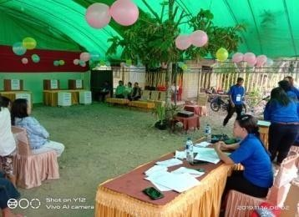
10. | KEC. DUMOGA TENGAH | 3. DESA  KINOMALIGAN | 2. RAMLI BUYONGI | 140
10. | KEC. DUMOGA TENGAH | 3. DESA  KINOMALIGAN | 3. HARIYONO BOBUYONGKI | 270
10. | KEC. DUMOGA TENGAH | 3. DESA  KINOMALIGAN | 4. HARTONO MODEONG | 214
10. | KEC. DUMOGA TENGAH | 4. DESA KOSIO BARAT | 1. AGUSTINA YOHANA TUNDO | 224 | 454 | 425 | 29 | 424 | 1 | 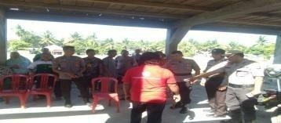
10. | KEC. DUMOGA TENGAH | 4. DESA KOSIO BARAT | 2. FENNY IRWAN SUID | 200

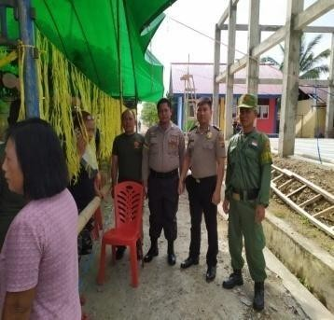
1 | 2 | 3 | 4 | 5 | 6 | 7 | 8 | 9 | 10 | 11
 |  | 5. DESA KOSIO TIMUR | 1. KENDI KUSNO HAMIM | 211 | 716 | 650 | 66 | 650 | - | 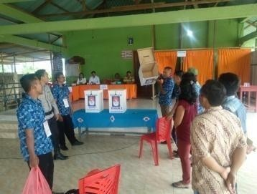
 |  | 5. DESA KOSIO TIMUR | 2. DJAKARIA NURHAMIDIN | -
 |  | 5. DESA KOSIO TIMUR | 3. SANCE V. MOONIK | 150
 |  | 5. DESA KOSIO TIMUR | 4. BURHAN MAKALALAG | 289
11. | KEC. DUMOGA TIMUR | 1. DESA  MOGOYUNGGU NG I | 1. ROBY KAWENGIAN | 304 | 552 | 515 | 37 | 515 | -
11. | KEC. DUMOGA TIMUR | 1. DESA  MOGOYUNGGU NG I | 2. BARTJE MICIJAIL TEWU | 211
11. | KEC. DUMOGA TIMUR | 2. DESA  MOGOYUNGGU NG II | 1. JULIUS TUMBELAKA | 375 | 730 | 661 | 69 | 658 | 3
11. | KEC. DUMOGA TIMUR | 2. DESA  MOGOYUNGGU NG II | 2. HANNA DEBORA SAYOW | 229
11. | KEC. DUMOGA TIMUR | 2. DESA  MOGOYUNGGU NG II | 3. ANEKE JEINE RORINGPANDEY | 54
11. | KEC. DUMOGA TIMUR | 3. DESA DUMOGA II | 1. RICHART F. LOMBAN | 277 | 568 | 568 | - | 561 | 7 | 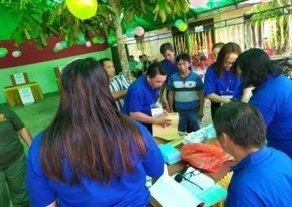
11. | KEC. DUMOGA TIMUR | 3. DESA DUMOGA II | 2. SAID MODEONG | 14
11. | KEC. DUMOGA TIMUR | 3. DESA DUMOGA II | 3. JUSTEN ANAU | 197
11. | KEC. DUMOGA TIMUR | 3. DESA DUMOGA II | 4. JAMES PAPISING | 13
11. | KEC. DUMOGA TIMUR | 4. DESA  KEMBANG SARI | 1. I WAYAN WIRTA | 351 | 587 | 487 | 100 | 487 | - | 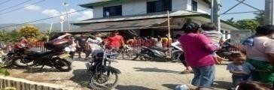
11. | KEC. DUMOGA TIMUR | 4. DESA  KEMBANG SARI | 2. I WAYAN SURA | 136
11. | KEC. DUMOGA TIMUR | 5. DESA  MODOMANG | 1. REFKI KARAUAN | 240 | 635 | 488 | 147 | 487 | 1 | 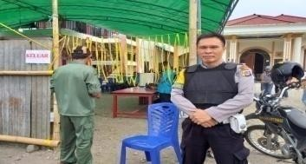
11. | KEC. DUMOGA TIMUR | 5. DESA  MODOMANG | 2. BIDWEL PINASANG | 104
11. | KEC. DUMOGA TIMUR | 5. DESA  MODOMANG | 3. DAUD EFRAIM PENDELAKI | 143
11. | KEC. DUMOGA TIMUR | 6. DESA AMERTA SARI | 1. I KOMANG BUDIAWAN | 241 | 569 | 482 | 87 | 482 | - | 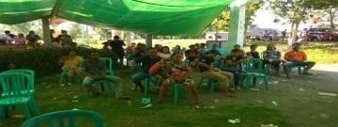
11. | KEC. DUMOGA TIMUR | 6. DESA AMERTA SARI | 2. I KETUT SUMARTA | 241

1 | 2 | 3 | 4 | 5 | 6 | 7 | 8 | 9 | 10 | 11
 |  | 7. DESA AMERTA BUANA | 1. I DEWA GEDE WIRIAWAN | 145 | 459 | 364 | 95 | 363 | 1 | 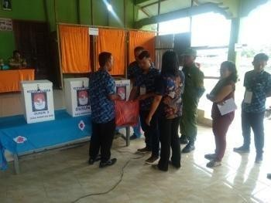
 |  | 7. DESA AMERTA BUANA | 2. I DEWA KETUT SUDIATMAJA | 172
 |  | 7. DESA AMERTA BUANA | 3. I DEWA GEDE SUMERJAYA | 41
 |  | 7. DESA AMERTA BUANA | 4. I DEWA GEDE YADNYA | 5
 |  | 8. DESA TONOM | 1. JEINE R. WALES | 496 | 1.196 | 1.047 | 149 | 1.041 | 6
 |  | 8. DESA TONOM | 2. TOMI WULUR | 87
 |  | 8. DESA TONOM | 3. STEVEN WEREH | 458
12. | KEC. DUMOGA BARAT | 1. DESA  MATAYANGAN | 1. RIDWAN DAENG PATAPA | 315 | 749 | 665 | 84 | 665 | - | 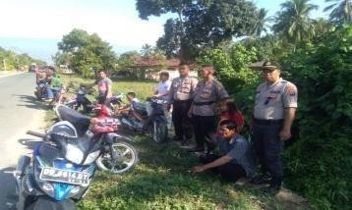
12. | KEC. DUMOGA BARAT | 1. DESA  MATAYANGAN | 2. SARIAMIN IGIRISA | 101
12. | KEC. DUMOGA BARAT | 1. DESA  MATAYANGAN | 3. FENNY LAATUNG | 249
12. | KEC. DUMOGA BARAT | 2. DESA UUWAN | 1. HARTO KOMALING | 934 | 1.654 | 1.364 | 290 | 1.351 | 13 | 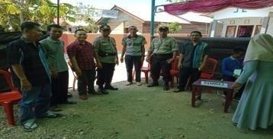
12. | KEC. DUMOGA BARAT | 2. DESA UUWAN | 2. DENNY BERTY UMBOH | 338
12. | KEC. DUMOGA BARAT | 2. DESA UUWAN | 3. SYAIDI HAMID | 79
12. | KEC. DUMOGA BARAT | 3. DESA IKHWAN | 1. ARIFIN NURHAMIDIN | 53 | 2.287 | 1.759 | 528 | 1.758 | 1 | 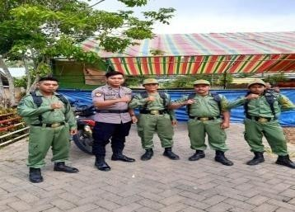
12. | KEC. DUMOGA BARAT | 3. DESA IKHWAN | 2. ARIFIN BUCHARI, SE | 827
12. | KEC. DUMOGA BARAT | 3. DESA IKHWAN | 3. SUARDI KABADERAN | 771
12. | KEC. DUMOGA BARAT | 3. DESA IKHWAN | 4. SYARIFUDIN MASHANAFI, SE | 107
12. | KEC. DUMOGA BARAT | 4. DESA TORAUT | 1. MASAUDIN MOKOAGOW | 555 | 1.070 | 1.010 | 60 | 1.010 | - | 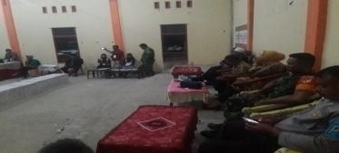
12. | KEC. DUMOGA BARAT | 4. DESA TORAUT | 2. HAMDI MOKOAGOW | 453
12. | KEC. DUMOGA BARAT | 4. DESA TORAUT | 3. ADE BONDE | 2

1 | 2 | 3 | 4 | 5 | 6 | 7 | 8 | 9 | 10 | 11
 |  | 5. DESA  MAKARUWO | 1. VANDA MAKARAUNG | 151 | 814 | 755 | 59 | 755 | - | 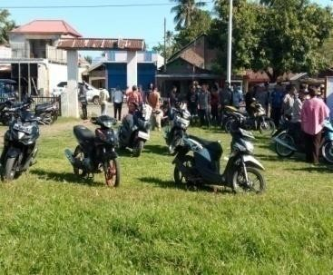
 |  | 5. DESA  MAKARUWO | 2. JOKLAN PANGKEY | 77
 |  | 5. DESA  MAKARUWO | 3. RICKY A. TEMO | 318
 |  | 5. DESA  MAKARUWO | 4. IRWAN K. BADERAN | 57
 |  | 5. DESA  MAKARUWO | 5. JENTRI GIPSI KORUA | 152
 |  | 6. DESA DOLODUO I | 1. AMIR DJANGKO | 170 | 598 | 485 | 113 | 485 | - | 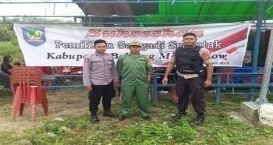
 |  | 6. DESA DOLODUO I | 2. GUNAWAN A. BONDE | 71
 |  | 6. DESA DOLODUO I | 3. RUBIANTO BONDE | 244
 |  | 7. DESA DOLODUO II | 1. SUPARDI RARUNG, BS.c | 57 | 437 | 405 | 32 | 402 | 3 | 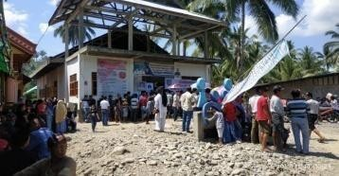
 |  | 7. DESA DOLODUO II | 2. WAWAN BONDE | 197
 |  | 7. DESA DOLODUO II | 3. MEIKE DIEN | 148
 |  | 8. DESA DOLODUO III | 1. IRAWAN MAMONTO | 219 | 390 | 368 | 22 | 368 | - | 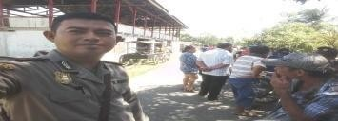
 |  | 8. DESA DOLODUO III | 2. AMIR WALAD BONDE | 149
13. | KEC. BILALANG | 1. DESA BILALANG III UTARA | 1. SUHU MOKOGINTA | 68 | 905 | 733 | 172 | 728 | 5 | 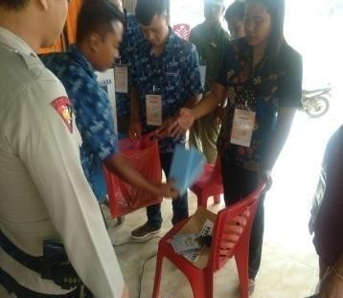
13. | KEC. BILALANG | 1. DESA BILALANG III UTARA | 2. TAMRIN MOKOGINTA | 56
13. | KEC. BILALANG | 1. DESA BILALANG III UTARA | 3. DEYSI M. OROH, S.Pd | 275
13. | KEC. BILALANG | 1. DESA BILALANG III UTARA | 4. MUDIN MOKOGINTA | 43
13. | KEC. BILALANG | 1. DESA BILALANG III UTARA | 5. RAHMAN SUGEHA | 286
13. | KEC. BILALANG | 2. DESA TUDUAIG | 1. URI MOKODONGAN | 224 | 646 | 410 | 36 | 610 | - | 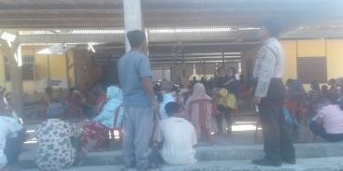
13. | KEC. BILALANG | 2. DESA TUDUAIG | 2. DUENG MOKODONGAN | 144
13. | KEC. BILALANG | 2. DESA TUDUAIG | 3. JENLI MOKOGINTA | 242

1 | 2 | 3 | 4 | 5 | 6 | 7 | 8 | 9 | 10 | 11
14. | KEC. PASSI BARAT | 1. DESA INUAI | 1. RUSLAN RAUF | 20 | 602 | 521 | 81 | 520 | 1 | 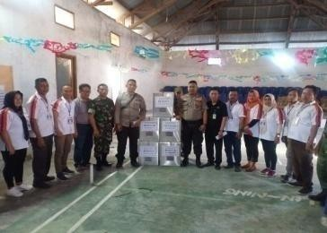
14. | KEC. PASSI BARAT | 1. DESA INUAI | 2. NEKA PAPUTUNGAN | 133
14. | KEC. PASSI BARAT | 1. DESA INUAI | 3. IMRAN MOMINTAN | 209
14. | KEC. PASSI BARAT | 1. DESA INUAI | 4. IDRIS MOMINTAN | 158
14. | KEC. PASSI BARAT | 2. DESA MUNTOI | 1. RUSMIN MOKODOMPIT, SE | 101 | 929 | 814 | 115 | 814 | - | 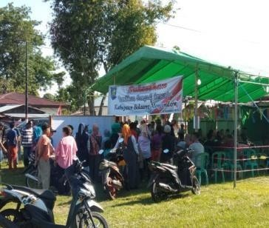
14. | KEC. PASSI BARAT | 2. DESA MUNTOI | 2. YULIANA K. TUNGGALI | 266
14. | KEC. PASSI BARAT | 2. DESA MUNTOI | 3. YUSMAN TUNGGALI | 115
14. | KEC. PASSI BARAT | 2. DESA MUNTOI | 4. HERMAN TAROREH | 70
14. | KEC. PASSI BARAT | 2. DESA MUNTOI | 5. SASILIA MOKODOMPIT | 262
14. | KEC. PASSI BARAT | 3. DESA MUNTOI TIMUR | 1. TRIS MOKODOMPIT | 10 | 550 | 415 | 135 | 415 | - | 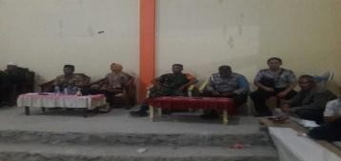
14. | KEC. PASSI BARAT | 3. DESA MUNTOI TIMUR | 2. Drs. BURHAMUDIN MOKODOMPIT | 241
14. | KEC. PASSI BARAT | 3. DESA MUNTOI TIMUR | 3. ALI SUBHAN MOKODONGAN | 164
14. | KEC. PASSI BARAT | 4. DESA  POYUYANAN | 1. WAHYUMI L. MAMONTO | 189 | 671 | 608 | 63 | 608 | - | 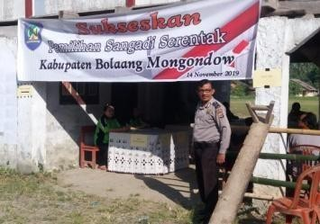
14. | KEC. PASSI BARAT | 4. DESA  POYUYANAN | 2. HASRUL MOKOAGOW | 39
14. | KEC. PASSI BARAT | 4. DESA  POYUYANAN | 3. RUSTAM MOKODOMPIT | 274
14. | KEC. PASSI BARAT | 4. DESA  POYUYANAN | 4. HAIDIR MOKODONGAN | 106
14. | KEC. PASSI BARAT | 5. DESA LOBONG | 1. SAMSUDIN HAMIM | 416 | 1.400 | 1.256 | 144 | 1.251 | 5 | 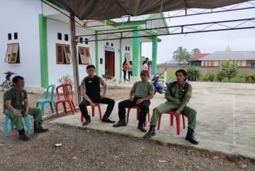
14. | KEC. PASSI BARAT | 5. DESA LOBONG | 2. RULI HASAN | 41
14. | KEC. PASSI BARAT | 5. DESA LOBONG | 3. RIFAY MOKOGINTA | 647
14. | KEC. PASSI BARAT | 5. DESA LOBONG | 4. RUSLAN MOKODOMPIT | 147

1 | 2 | 3 | 4 | 5 | 6 | 7 | 8 | 9 | 10 | 11
 |  | 6. DESA  WANGGA | 1. MASRI MOKOAGOW | 429 | 616 | 494 | 122 | 493 | 1 | 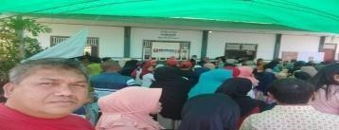
 |  | 6. DESA  WANGGA | 2. ASRA MAMONTO | 64
 |  | 7. DESA  WANGGA I | 1. ARSAD POTABUGA | 282 | 584 | 555 | 29 | 552 | 3 | 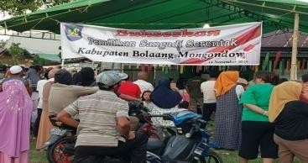
 |  | 7. DESA  WANGGA I | 2. HISAM YAMBAT | 270
 |  | 8. DESA OTAM BARAT | 1. SUKARDI KOLOPITA | 57 | 1.044 | 962 | 82 | 956 | 6 | 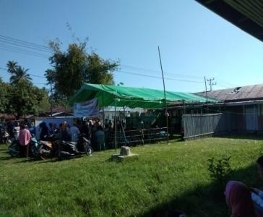
 |  | 8. DESA OTAM BARAT | 2. LEKU POPI HAMIM | 251
 |  | 8. DESA OTAM BARAT | 3. HASUUT MOKODOMPIT, Ama.Pd | 225
 |  | 8. DESA OTAM BARAT | 4. IMPA GINOGA, S.Pd | 275
 |  | 8. DESA OTAM BARAT | 5. NIKMAT MOKODOMPIT | 148
 |  | 9. DESA BULUD | 1. GUNAWAN MOKODOMPIT | 114 | 791 | 701 | 90 | 695 | 5 | 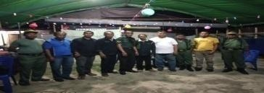
 |  | 9. DESA BULUD | 2. NURHADIN MOKODOMPIT | 582
15. | KEC. PASSI TIMUR | 1. DESA  MANEMBO | 1. YORI GERT RATU | 233 | 770 | 723 | 47 | 721 | 2 | 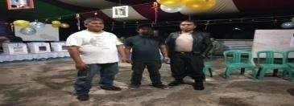
15. | KEC. PASSI TIMUR | 1. DESA  MANEMBO | 2. MERDI PURUKAN | 488
15. | KEC. PASSI TIMUR | 2. DESA POOPO | 1. HELMI MOUDY RATTU | 316 | 805 | 771 | 34 | 770 | 1 | 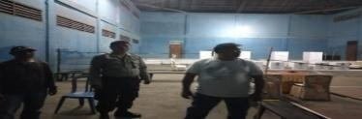
15. | KEC. PASSI TIMUR | 2. DESA POOPO | 2. IRENE TAMBAYONG | 454
15. | KEC. PASSI TIMUR | 3. DESA POOPO SELATAN | 1. MARTINUS B. RUMENGAN | 137 | 659 | 624 | 35 | 624 | - | 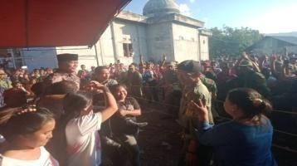
15. | KEC. PASSI TIMUR | 3. DESA POOPO SELATAN | 2. JINY MOONIK | 416
15. | KEC. PASSI TIMUR | 3. DESA POOPO SELATAN | 3. JORMAN MANANSAL | 71

1 | 2 | 3 | 4 | 5 | 6 | 7 | 8 | 9 | 10 | 11
 |  | 4. DESA POOPO BARAT | 1. JOHANIS HERMAN MOMONGAN | 291 | 649 | 605 | 44 | 603 | 2 | 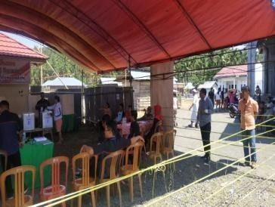
 |  | 4. DESA POOPO BARAT | 2. DENI B. TAMBAYONG | 11
 |  | 4. DESA POOPO BARAT | 3. FEIN LUMI, S.Pd | 253
 |  | 4. DESA POOPO BARAT | 4. AGUSTINUS WUNGOW | 48
 |  | 5. DESA PANGIAN | 1. GRACE WAURAN | 312 | 831 | 757 | 74 | 755 | 2 | 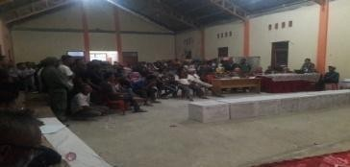
 |  | 5. DESA PANGIAN | 2. DEYSI RISTA SARI TABO | 192
 |  | 5. DESA PANGIAN | 3. SANDRA NGANTUNG | 251
 |  | 6. DESA PANGIAN TENGAH | 1. WETI POTABUGA | 150 | 885 | 833 | 52 | 833 | - | 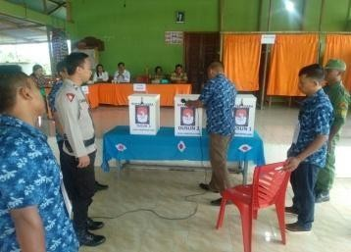
 |  | 6. DESA PANGIAN TENGAH | 2. BOLIN TIWANG | 166
 |  | 6. DESA PANGIAN TENGAH | 3. INDRIS SIPASI | 355
 |  | 6. DESA PANGIAN TENGAH | 4. ABRAM SUBU | 162
 |  | 7. DESA  SINSINGON | 1. AGUSTIN H. DAMPI, SKM | 5 | 566 | 541 | 25 | 536 | 5 | 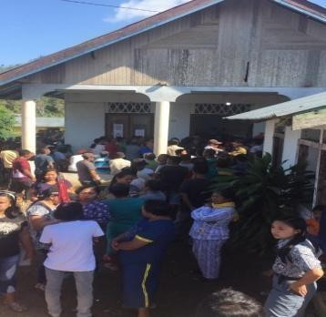
 |  | 7. DESA  SINSINGON | 2. FRANTI RUMONDOR, SH | 184
 |  | 7. DESA  SINSINGON | 3. MARGO M. MOONIK | 31
 |  | 7. DESA  SINSINGON | 4. DENVI SINGAL, SE | 156
 |  | 7. DESA  SINSINGON | 5. NELDIN MOMONGAN | 160
 |  | 8. DESA  SINGSINGON TIMUR | 1. FEKI PESIK | 264 | 523 | 505 | 18 | 485 | 2 | 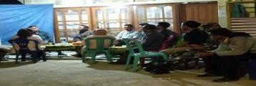
 |  | 8. DESA  SINGSINGON TIMUR | 2. CENLI MOONIK | 221
 |  | 9. DESA INSIL | 1. MUKSIN MOKOGINTA | 470 | 727 | 712 | 15 | 712 | - | 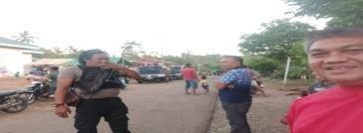
 |  | 9. DESA INSIL | 2. SAMSU MOKOGINTA | 242

1 | 2 | 3 | 4 | 5 | 6 | 7 | 8 | 9 | 10 | 11
 |  | 10. DESAINSIL BARU | 1. MULIADI MOKOGINTA | 278 | 576 | 562 | 14 | 561 | 1 | 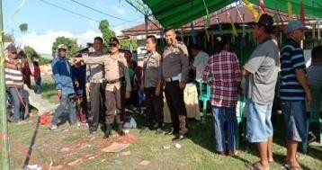
 |  | 10. DESAINSIL BARU | 2. RELITA MOKOGINTA | -
 |  | 10. DESAINSIL BARU | 3. MASHURI MOKOGINTA | 283

Lolak, 15 November 2019

ASISTEN ADMINISTRASI PEMERINTAHAN DAERAH KABUPATEN BOLAANG MONGONDOW

B. D. PANAMBUNAN, SE PEMBINA UTAMA MUDA NIP. 19591218 198303 1 013

